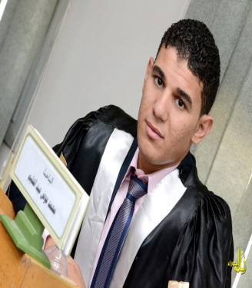
Assiut University
Faculty of Physical Education
Department of Curriculum and teaching of Physical Education
Name: Mohamed Awad Abdel Halim
Date of Birth: 05/01/1990 Nationality: Egyptian
Marital status: Single Religion: Muslim
E-mail: moh.awad2011@yahoo.com
E-academic Muhamm.awad@phyedu.au.edu.eg
Tel: 01067079473
Position
:
Assistant Lecturer, Department of Curriculum and teaching of Physical Education
Organization It: Faculty of Physical Education. Assiut University
Department: Department of Curriculum and teaching of Physical Education
Major: Physical Education
Specialization: teaching handball
Name of qualification obtained Specialization date of acquisition
- Bachelor of Physical Education College of Physical Education - Assiut University Handball 2011
- Master of Physical Education College of Physical Education - Assiut University Handball 2014
- Teaching Assistant, Department of Curriculum and teaching of Physical Education. Assiut University. Handball allocated as of 2011.
- Assistant Lecturer, curricula and teaching Physical Education Department. Assiut University. Handball allocated as of 2014.
- Handball player Sohag region in the period from 2000 until 2007.
- Team handball coach Girls College of Education sports Assiut University.
- Ambassador of the Information Technology Unit, Department of Curriculum and teaching of Physical Education College of Physical Education Assiut University.
- Supervising the camps Scout first aid in the period of 2011 to 2015 m.
- Ruling handball area Assiut.
- Member of the steering committee and governance within the Quality Committee at the Faculty of Physical Education Assiut University
- Participated in many student conferences.
- Orascom cycle of human development.
- English course at the Faculty of Literature Assiut University.
- Proficiency in English language course at the Faculty of Arts, Assiut University (ELPT)
- The capacity of faculty members at the University of Assiut development cycles.
- Coors BY LAWS N & CONTROL AFFAIRS of the training center on information and communication technology (ICTB)
- Holds a training course in the statistical software (SPSS) of the Training Centre for Information and Communication Technology (ICTB)
- Holds a training program (TOP PLAY & TOP SPORT) of the British Council
- Holds a program many of the certificates of appreciation for scientific excellence and active participation in the activities and student conferences.

